UUCWC COUNTDOWN TO THE HOLIDAYS HOLHOLIDAYS | Dec 2022
Sunday | Monday | Tuesday | Wednesday | Thursday | Friday | Saturday
 |  |  | 14 | 15 | 16 | 17
 |  |  | Bring new hats, mittens, gloves to UUCWC to donate to our HomeFront Mitten Tree. | Light a chalice or candle before dinner. Share a Joy or Sorrow.  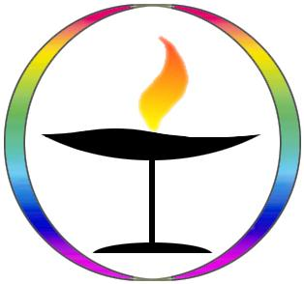 | 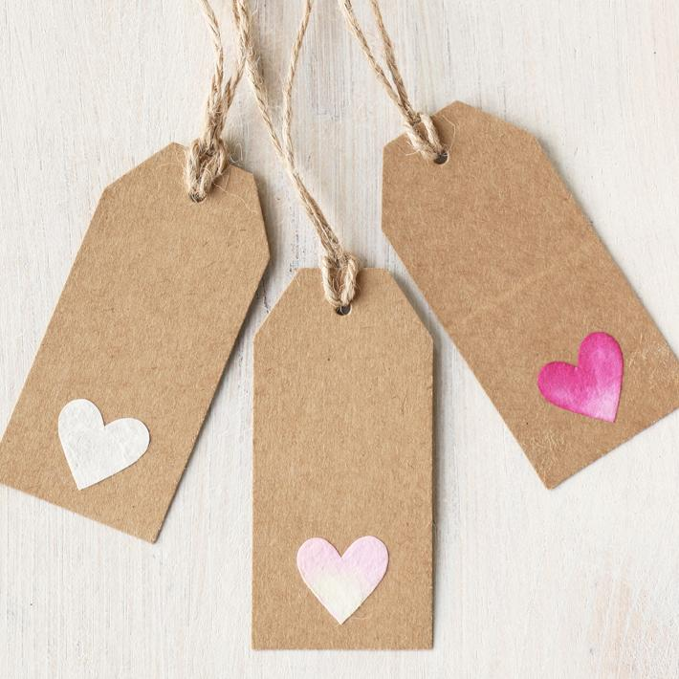  Grateful for our UUCWC community? Give an End of Year Gift in celebration of UUCWC. | 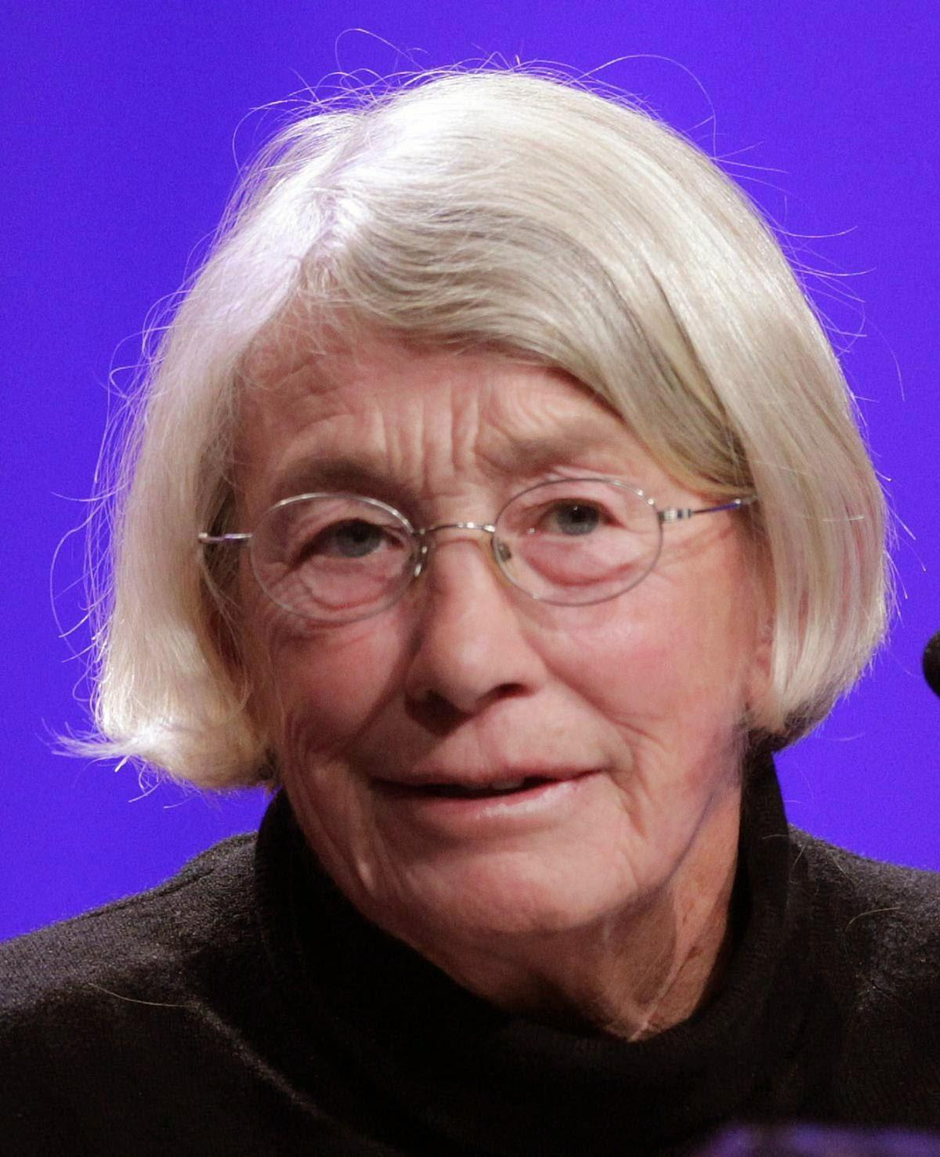  Look up Mary Oliver, Naomi Shihab Nye, or Richard Blanco poems on the Internet.
18 | 19 | 20 | 21 | 22 | 23 | 24
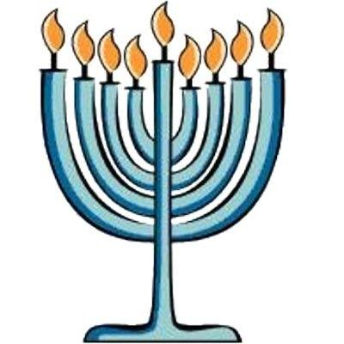  Soprano Megnot Toggia sings at our service. Bake Sale & Boutique after services. Light the first candle in the Menorah tonight. “Happy Hannukah!” | Reach out to someone from UUCWC you haven’t spoken to in a while! | Invite a friend or neighbor to UUCWC’s Christmas Eve service. | 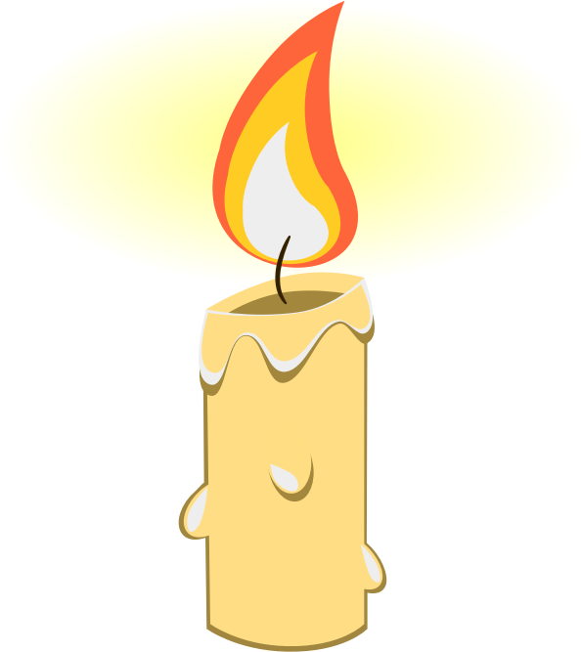  Join Rev. Kim for a Blue Christmas service at 7:30pm Light a candle to observe the solstice. | Holiday Sweater Selfie: post a picture of yourself in earnest or ironic holiday attire on the Community Building Facebook page. | Go outside alone. Take five breaths. Send loving kindness to our congregation and to someone in need. | Join us for Christmas Eve Service at 8pm.  If joining online, don’t forget to get your candles ready.
25 | 26 | 27 | 28 | 29 | 30 | 31
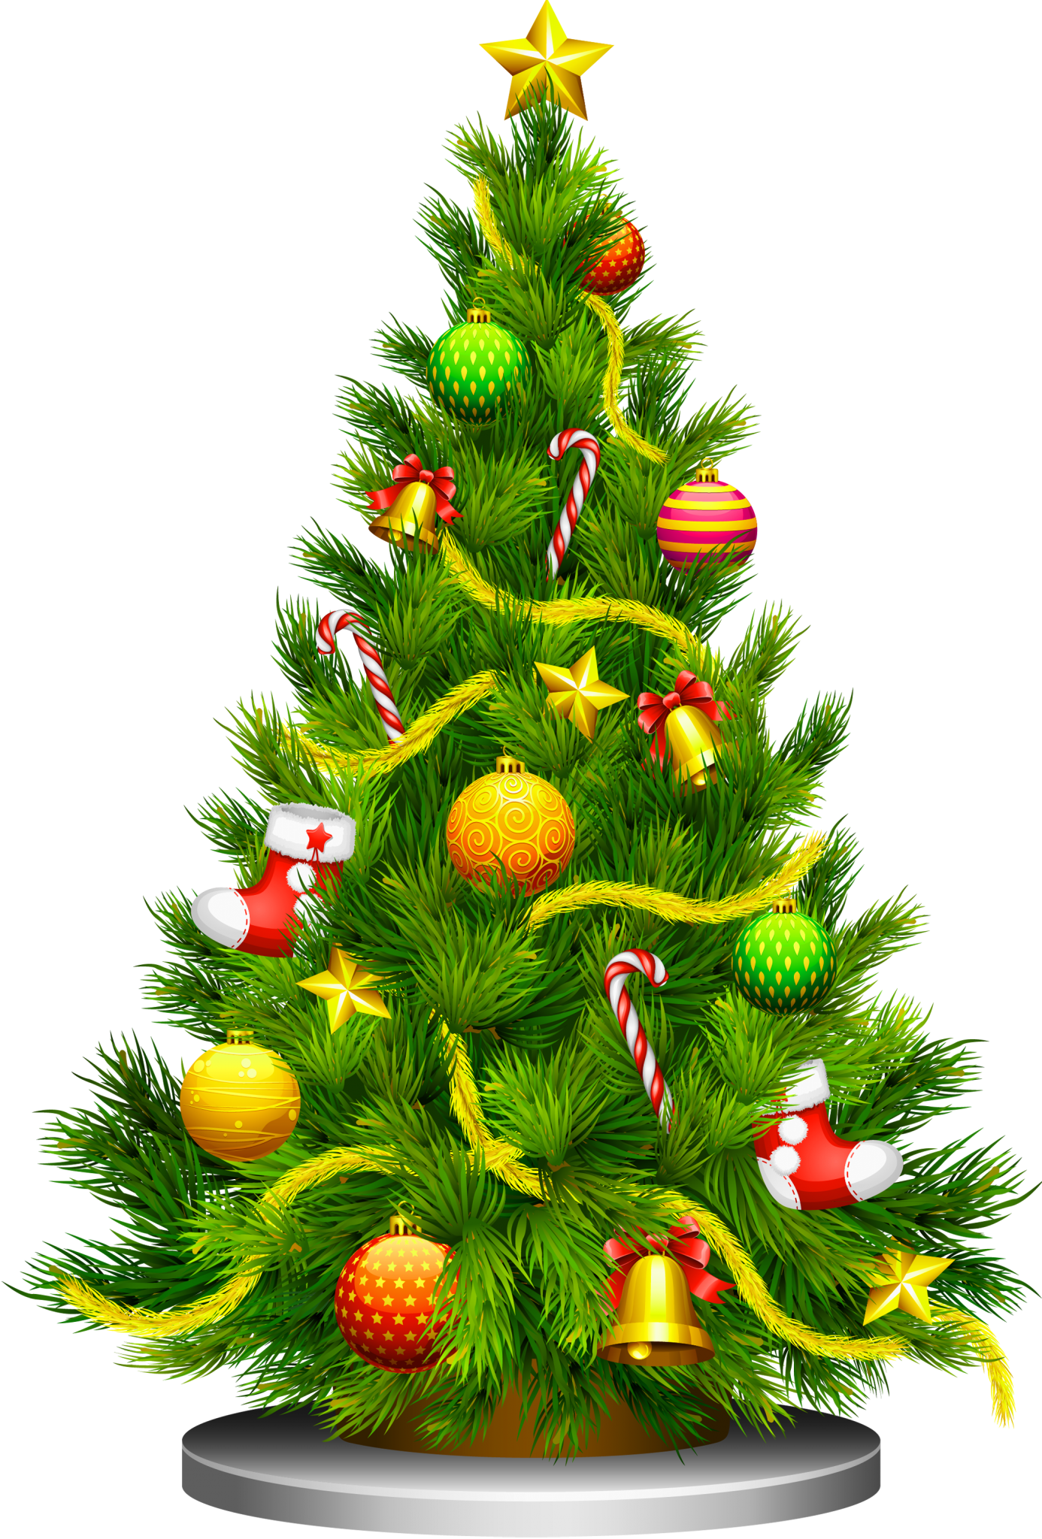  Christmas Service online only: Rev Kim joins UU ministers and congregations across the country sing hymns, share readings, and reflections of Christmas.  “Merry Christmas!” | Your gift by Dec. 31st of an End of Year donation supports UUCWC and may be a year-end tax deduction for 2022. | Send a thank you note to a board, committee or ministry leader. | Create a Home Altar that honors the past & sets intentions for the new year. Post a picture of it on the FaceBook Community Building page | 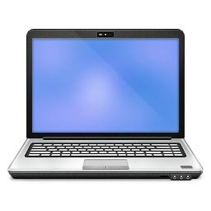  Visit the UUCWC website and find one new activity or committee to try in January. | Thank yourself for five kind things you did in 2022. | Write yourself a note about something you want to learn or do in the New Year.
January 1
New Year’s Day Service Online Only. Congregants from different generations reflect on “What change did you experience or what mattered because you were somewhere at some point in time?” | Coming in 2023:  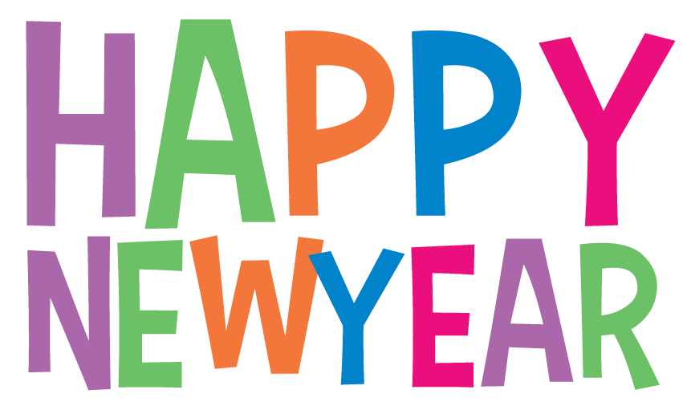  - Our Whole Lives (OWL) age appropriate sexuality education for grades 1-6, and 9-12 begins 2/5 (grades 7-8 are in a year-long OWL program); parent orientation in January  - Path to Membership Spring class  - New Adult Faith Engagement classes coming  - Continuation of our guest musician series & some exciting Sunday afternoon concerts  - Auction sermons, Lectio Divina and more from Rev. Kim  - News on our Capital Campaign project  - Auction, Pledge Drive, Child dedications and more!
We invite you to another year of engagement as we
Create Community, Celebrate Life, Change the World

