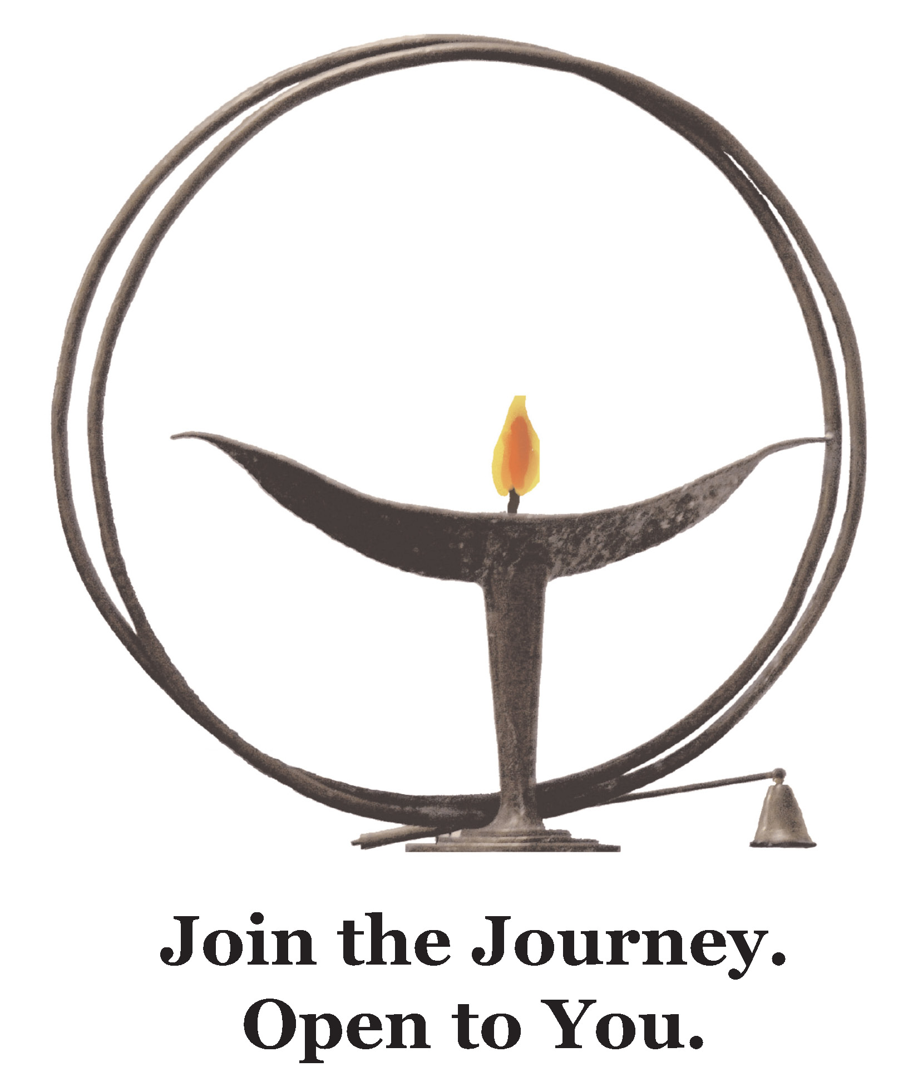

Rocks and Ropes and Solos:
Reflections on Inward and Outward Journeys
March 29, 2020 Online Service 10am
Creating Community, Celebrating Life, Changing the World

Gathering Music Greg Pontier

Welcome Bay Waltman

Lighting the Chalice Bay Waltman

Story for All Ages Robin Pugh

Hymn “Spirit of Life” Greg Pontier
Spirit of Life, come unto me.
Sing in my heart all the stirrings of compassion,
Blow in the wind, rise in the sea;
move in the hand, giving life the shape of justice.
Roots hold me close; wings set me free:
Spirit of life, come to me, come to me.

Sermon “Rocks and Ropes and Solos” Bay Waltman

Reflective Music Greg Pontier

Financial Affirmation Jim Sanders

Closing Music Greg Pontier

Parting Words Bay Waltman

Extinguishing the Chalice Bay Waltman

Special Thanks to Worship Associate Co-Chair Bay Waltman for leading the service; Robin Pugh, Director of Lifespan Religious Education for our story; Greg Pontier for our Music; Jim Sanders, Board Treasurer for our Financial Affirmation; and Worship Associate Co-Chair Scott Cullen as “tech host”.

